**ECEN 449-504**

**William Liu**

**Lab 8 Report**

**Purpose:** The purpose of this lab is to create a driver for the IR remote receiver by using an interrupt signal instead of polling continuously for the signal to appear.

**Procedure:**

1. Create the IR receiver circuit
2. Create the Zynq processing system in Vivado
3. Add the IR_demodulator peripheral to the Zynq processing system
4. Add an IR_interrupt signal into the verilog code for the peripheral for when a message appears
5. Add an IR_interrupt output to the peripheral and set it to an external port in the block diagram
6. Add the IR_interrupt pin to the .xdc constraints file
7. Write the software to read from the message register and the interrupt register
8. Using the output pin defined in the .xdc file, check that the interrupt signal shows up correctly on the oscilloscope.
9. After verifying that the signal works, remove the external port from the block diagram and edit the PS IP Interrupts section. Add a fabric interrupt called IRQ_F2P[15:0] and connect the peripheral interrupt output to the input of the fabric interrupt in the PS block diagram.
10. Write the device driver for the peripheral for Linux
11. Create BOOT.bin, edit the .dts file to include the ir_demod peripheral
12. Create a devtest file to test the device driver

**Results:**

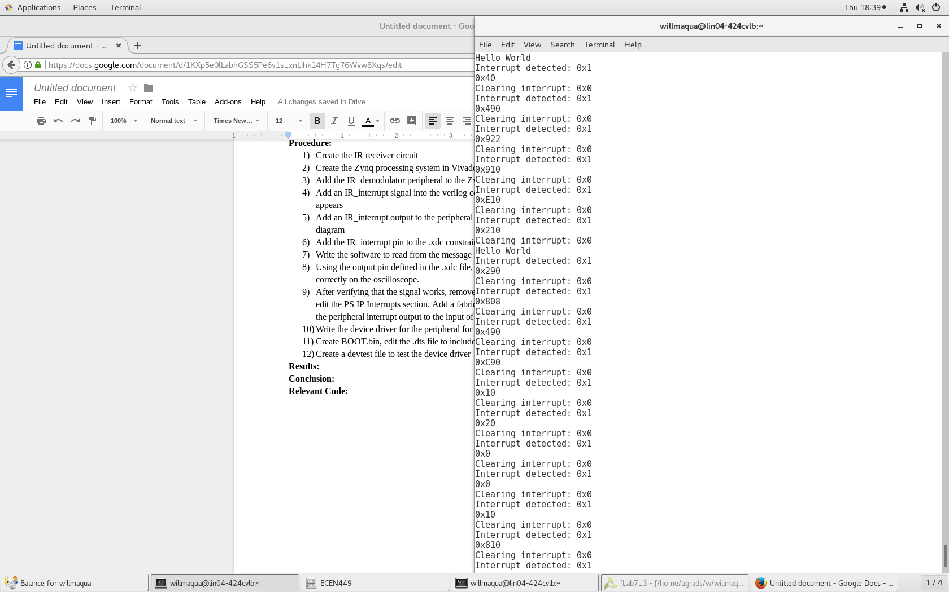

**Conclusion:**

By using an interrupt signal instead of polling for input continually, more CPU time is made available for use by other processes instead of it being used to wait for empty messages repeatedly. In this situation, an interrupt signal works well because the user will not always be pushing buttons on the remote repeatedly. If data were to come in continuously, polling for input would be a reasonable design.

**Relevant Code:**

**C file**

#include "platform.h"

#include <xil_printf.h>

#include <ir_demod.h>

#include <xparameters.h>

#define XPAR_IR_DEMOD_0_DEVICE_ID IR_DEMOD

#define WAIT_VAL 20000000

int delay(void);

int main()

{

init_platform();

u32 readmsg = 0;

u32 baseAddr = XPAR_IR_DEMOD_0_S00_AXI_BASEADDR;

u32 oldmsg = 1;

u32 msgCounter = 0;

u32 oldmsgCounter = 1;

u32 readStart = 0;

xil_printf("Hello World\n\r");

while(1){

//xil_printf("Message read: 0x%x\n\r", readmsg);

u32 reg2 = IR_DEMOD_mReadReg(baseAddr, IR_DEMOD_S00_AXI_SLV_REG2_OFFSET); //read for iterrupt signal

//xil_printf("reg2: 0x%x\n\r", reg2);

if(reg2 == 1){

xil_printf("Interrupt detected: 0x%x\n\r", reg2);

//read a message

readmsg = IR_DEMOD_mReadReg(baseAddr, IR_DEMOD_S00_AXI_SLV_REG0_OFFSET);

//notify peripheral to clear interrupt bit

IR_DEMOD_mWriteReg(baseAddr, IR_DEMOD_S00_AXI_SLV_REG2_OFFSET, 0xFFFF0000);

xil_printf("0x%x\n\r", readmsg);

//verify the interrupt is cleared

u32 clrreg2 = IR_DEMOD_mReadReg(baseAddr, IR_DEMOD_S00_AXI_SLV_REG2_OFFSET);

xil_printf("Clearing interrupt: 0x%x\n\r", clrreg2);

}

//delay();

}

cleanup_platform();

return 0;

}

int delay(void){

volatile int delay_count=0;

while(delay_count < WAIT_VAL)

delay_count++;

return(0);

}

**IR_demod peripheral**

reg[31:0] counter;

reg[11:0] message;

reg[31:0] recvAmt;

reg[11:0] prevMessage;

reg[4:0] bitCounter;

wire posedge_detected;

wire negedge_detected;

reg signal_dp;

reg signal_dn;

reg clr_int_rst;

initial begin

counter = 0;

message = 0;

bitCounter = 11;

slv_reg0 = 0;

prevMessage = 0;

slv_reg2[0] = 0;

recvAmt = 0;

end

always@(posedge S_AXI_ACLK) begin

signal_dp <= IR_signal;

signal_dn <= IR_signal;

counter <= counter + 1;

clr_int_rst <= 0; //clear interrupt signal should be 0 by default

if(slv_reg2[16] == 1) begin

clr_int_rst <= 1; //clear interrupt signal when software receives message

slv_reg2[0] <= 0;

end

if(negedge_detected) begin

counter <= 0;

end

if(posedge_detected) begin

if(counter <= 50000) begin

message[bitCounter] <= 0;

bitCounter <= bitCounter - 1;

if(bitCounter == 0) begin

slv_reg0[11:0] <= message;

recvAmt <= recvAmt + 1;

slv_reg2[0] <= 1; //set interrupt signal HIGH

end

end

else if(counter > 50000 && counter <= 95000) begin

message[bitCounter] <= 1;

bitCounter <= bitCounter - 1;

if(bitCounter == 0) begin

slv_reg0[11:0] <= message;

recvAmt <= recvAmt + 1;

slv_reg2[0] <= 1; //set interrupt signal HIGH

end

end

else if(counter > 95000 && counter <= 187000) begin

bitCounter <= 11;

prevMessage <= message;

message <= 0;

/*if(slv_reg2[16] == 1) begin

clr_int_rst <= 1;

slv_reg2[0] <= 0;

end*/

end

end

end

assign posedge_detected = !signal_dp && IR_signal;

assign negedge_detected = signal_dn && !IR_signal;

assign IR_interrupt = slv_reg2[0]; //tie internal interrupt signal to output of peripheral